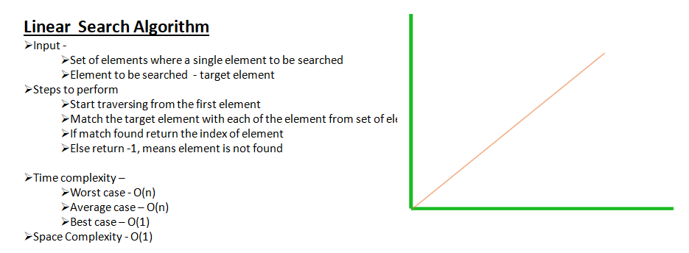

**public** **static** **void** main(String[] args) {

**int** dataSet[] = { 10, 12, 34, 21, 12, 56 };

*searchElement*(dataSet, 34);

}

**private** **static** **void** searchElement(**int**[] dataSet, **int** target) {

**long** start = System.*nanoTime*();

**boolean** found = **false**;

**int** index;

**for** (index = 0; index < dataSet.length; index++) {

**if** (target == dataSet[index]) {

found = **true**;

**break**;

}

}

System.***out***.println("Time" + (System.*nanoTime*() - start) + " nanosecond");

**if** (found) {

System.***out***.println("Element found at index - " + index);

} **else** {

System.***out***.println("Element is not in data set");

}

}

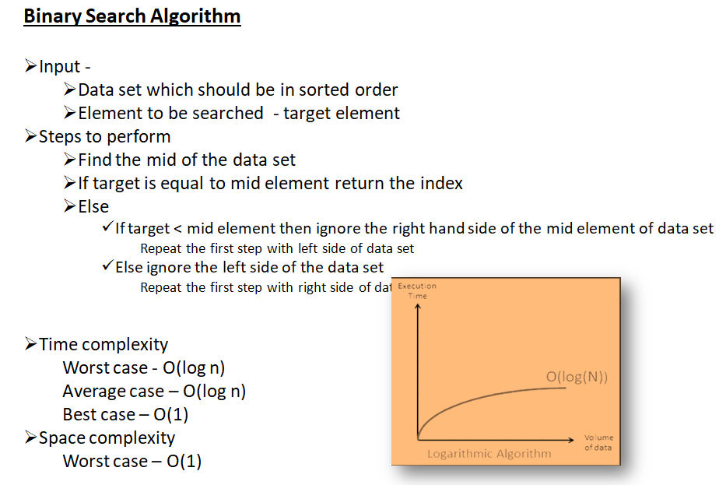

**public** **static** **void** main(String[] args) {

**long** start = System.*nanoTime*();

**int** dataSet[] = { 10, 12, 34, 21, 12, 56 };

**int** index = *doBinarySearch*(dataSet, 34);

System.***out***.println("Time :" + (System.*nanoTime*() - start) + " nanosecond");

**if** (index != Integer.***MIN_VALUE***) {

System.***out***.println("Element found in data set at index - " + index);

} **else** {

System.***out***.println("Element is not in data set");

}

}

**private** **static** **int** doBinarySearch(**int**[] dataSet, **int** target) {

**int** start = 0;

**int** end = dataSet.length - 1;

**int** totalIterations = 0;

**int** index = Integer.***MIN_VALUE***;

**while** (start <= end) {

totalIterations++;

**int** mid = (end + start) / 2;

**if** (target == dataSet[mid]) {

index = mid;

**break**;

} **else** **if** (target < dataSet[mid]) {

end = mid - 1;// ignoring the right side of the mid

} **else** {

start = mid + 1;// ignoring the left side of the mid

}

}

System.***out***.println("**** Total iterations - " + totalIterations);

**return** index;

}

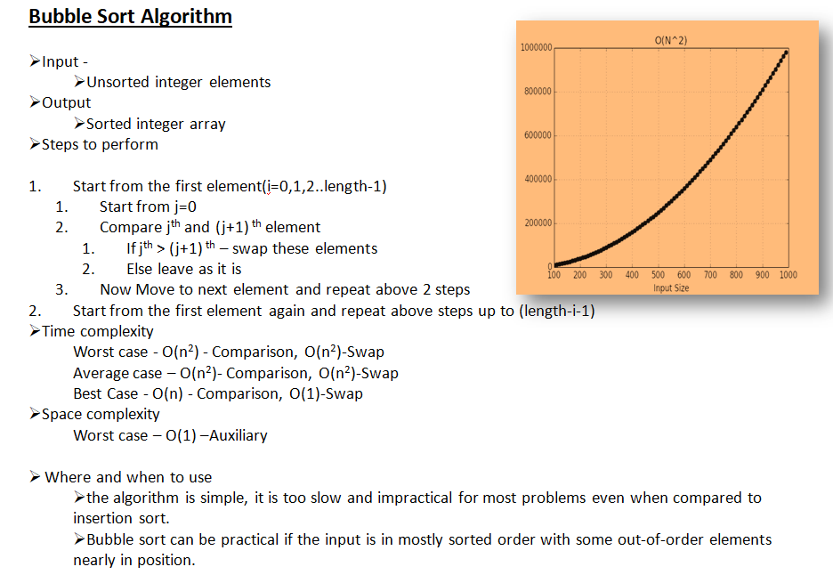

**public** **static** **void** main(String[] args) {

**int** dataSet[] = { 10, 102, 12, 34, 21, 12, 56 };

System.***out***.println("Before sorting: " + Arrays.*toString*(dataSet));

*bubbleSort*(dataSet);

System.***out***.println("After sorting: " + Arrays.*toString*(dataSet));

}

**private** **static** **void** bubbleSort(**int**[] dataSet) {

**int** length = dataSet.length;

**boolean** isSwapHappened = **false**;

**int** counter = 0;

**for** (**int** i = 0; i < length - 1; i++) {

**for** (**int** j = 0; j < length - i - 1; j++) {

**if** (dataSet[j] > dataSet[j + 1]) {

**int** temp = dataSet[j];

dataSet[j] = dataSet[j + 1];

dataSet[j + 1] = temp;

isSwapHappened = **true**;

}

counter++;

}

**if** (!isSwapHappened) {

**break**;

}

}

System.***out***.println("Total iterations to perform sorting- " + counter);

}

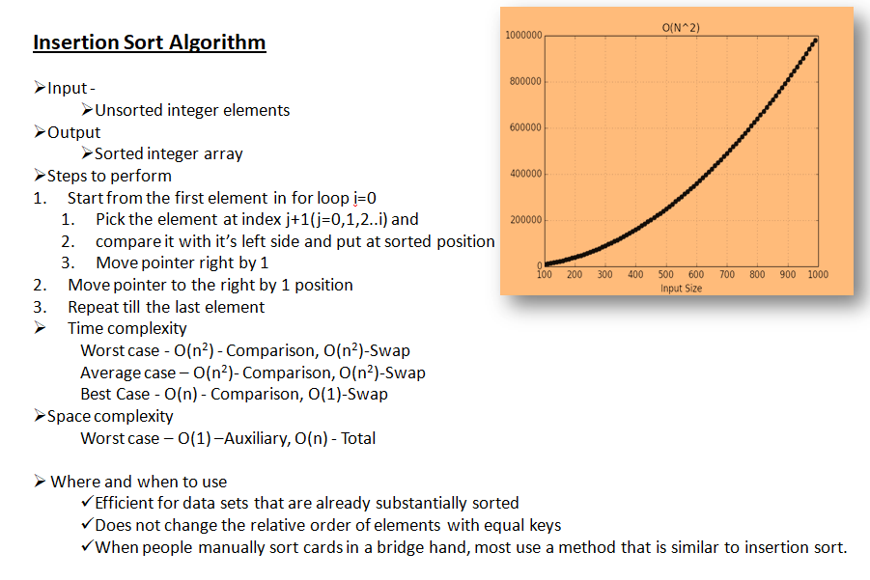

**public** **static** **void** main(String[] args) {

**int** dataSet[] = { 10, 102, 12, 34, 21, 12, 56 };

System.***out***.println("Before sorting: " + Arrays.*toString*(dataSet));

*sortElementsInInsertionSortWay*(dataSet);

System.***out***.println("After sorting: " + Arrays.*toString*(dataSet));

}

**private** **static** **void** sortElementsInInsertionSortWay(**int**[] dataSet) {

**int** length = dataSet.length;

**int** counter = 0;

**for** (**int** i = 0; i < length; i++) {

**int** key = dataSet[i];

**int** j = i - 1;

**while** (j >= 0 && dataSet[j] > key) {

dataSet[j + 1] = dataSet[j];

j--;

counter++;// counts the total iterations(not part of the algo)

}

dataSet[j + 1] = key;

counter++;// counts the total iterations(not part of the algo)

}

System.***out***.println("Total iterations to perform sorting- " + counter);

}

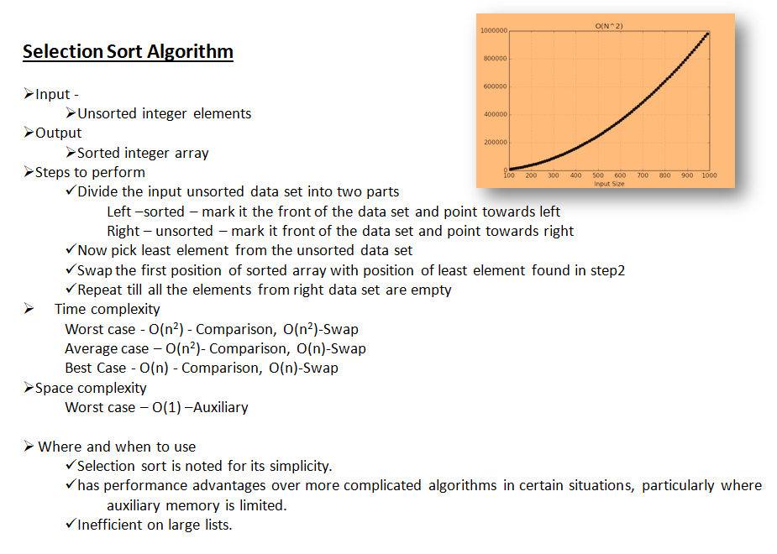

**public** **static** **void** main(String[] args) {

**int** dataSet[] = { 10, 102, 12, 34, 21, 12, 56 };

System.***out***.println("Before sorting: " + Arrays.*toString*(dataSet));

*sortElementsInSelectionSortWay*(dataSet);

System.***out***.println("After sorting: " + Arrays.*toString*(dataSet));

}

**private** **static** **void** sortElementsInSelectionSortWay(**int**[] dataSet) {

**int** length = dataSet.length;

**int** counter = 0;

**for** (**int** i = 0; i < length - 1; i++) {

**int** min = i;

**for** (**int** j = i + 1; j < length; j++) {

**if** (dataSet[j] < dataSet[min]) {

min=j;//found min

}

counter++;

}

**if** (min != i) {// if true then there is new min element

**int** temp = dataSet[min];

dataSet[min] = dataSet[i];

dataSet[i] = temp;

}

}

System.***out***.println("Total iterations to perform sorting- " + counter);

}